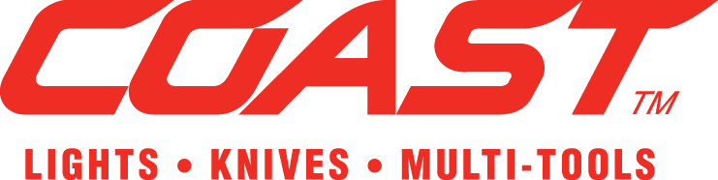 PRESS RELEASE

NEW LAUNCHES AT EMERGENCY SERVICES SHOW 2021!

Leading Global LED Torch brand ‘COAST’ is launching 9 new products from September 2020, all of which felt to be of particular interest for Emergency Services personnel and SAR volunteers.

**“XP-R” - Extreme-Performance, Rechargeable (Dual-Power) Focusing Torches:**

A series of 4 new ‘state-of-the-art’ Torches with “super-lumens” light outputs plus a host of additional ‘industry-leading’ features!

The range begins with the compact **XP6R at 400 lumens**, moving to the **XP9R at 1000 lumens**, the **XP11R at 2100 lumens** and ending with the flagship **XP18R at a massive 3650 lumens** maximum light output

**All 4 models are “Dual Power”,** designed **to work with the COAST ‘*ZITHION-X™’*  Rechargeable battery** (supplied as standard) but **also designed to operate from Primary/Single-use CR123A, AAA or AA batteries** if/when required to do so.

All 4 models feature **one-handed slide focus adjustment** from **long-range spot beam to COAST’s flawless ultra-wide flood beam** in addition to a new contoured body shape providing improved grip & comfort

**Added features on XP11R & XP18R** models include **an extra ‘TURBO mode’** of 2000 and 3500 lumens respectively, **also an illuminated Battery Life Indicator** built into the switch , so you always know how much power you have left in the tank!

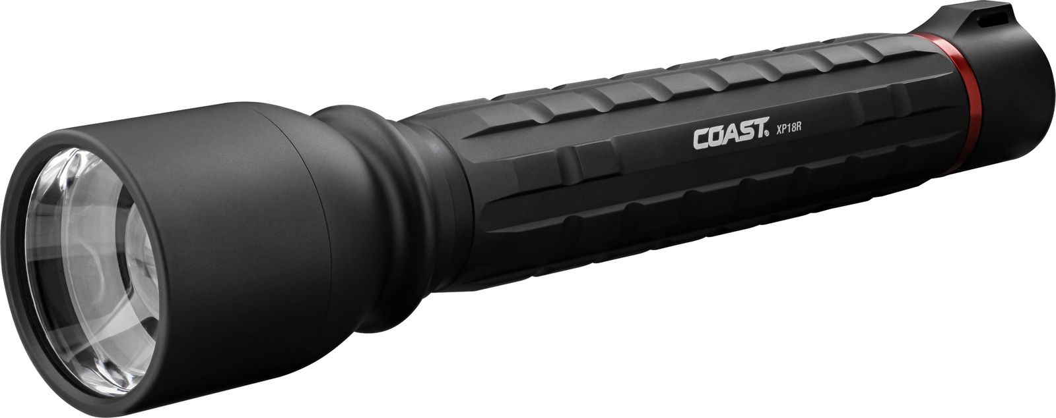***Highly competitive prices to Emergency Services personnel begin at £35 (XP6R) to £85 (XP18R)!***

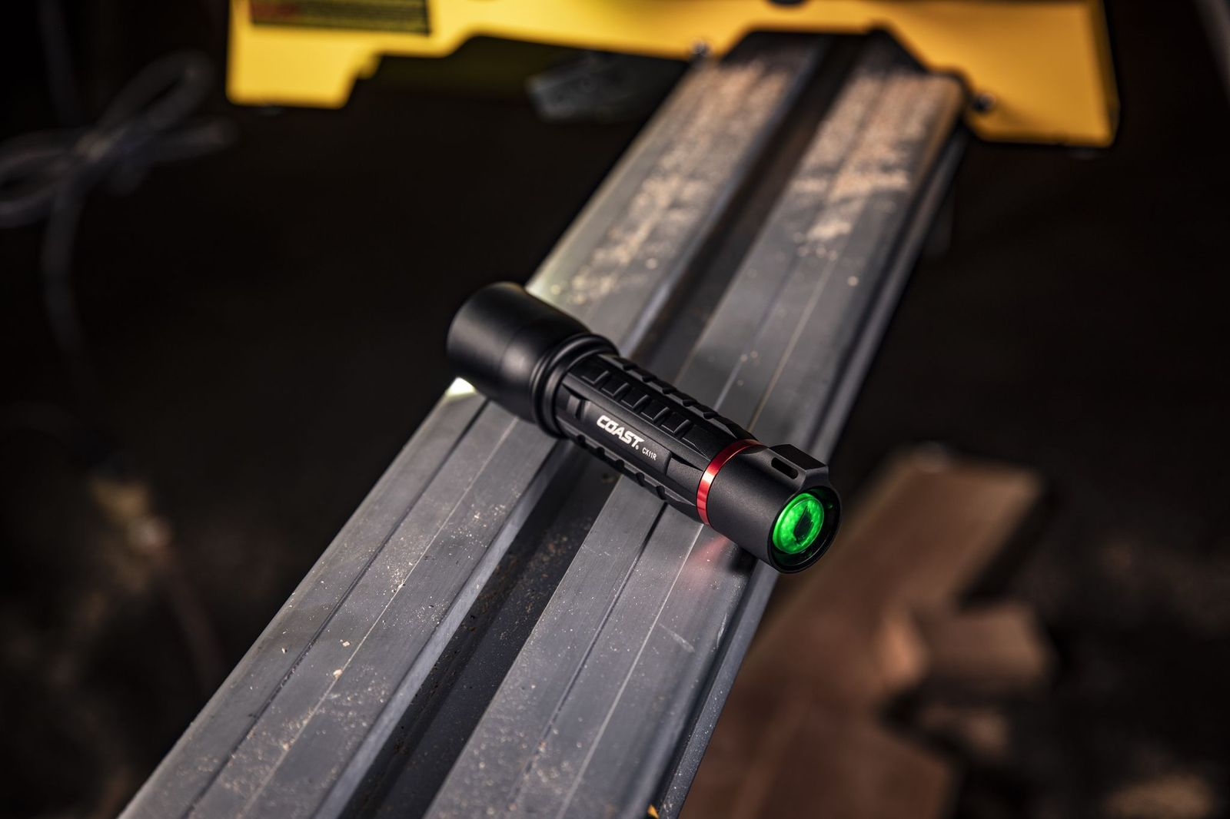

Inbuilt Battery Life Indicator

**“XPH-R” Super-Powered, Rechargeable (Dual-Power) Focusing Head-Torches:**

A series of 3 new ‘state-of-the-art’ Torches with “super-lumens” light outputs plus a host of additional ‘industry-leading’ features!

The range begins with the compact **XPH25R at 400 lumens**, moving to the **XPH-30R at 1000 lumens**, and ending with the flagship **XPH-34R at a massive 2075 lumens** maximum light output

**All 3 models are “Dual Power”,** designed **to work with the COAST ‘*ZITHION-X™’*  Rechargeable battery** (supplied as standard) but **also designed to operate from Primary/Single-use CR123A OR AA batteries** if/when required to do so.

All 3 models feature **one-handed twist focus adjustment** from **long-range spot beam to COAST’s flawless ultra-wide flood beam** in addition to a new heavy-duty contoured body.

**Added features on all 3** **models** include **a magnetic end-cap, enabling the torch to be detached & used as a hands-free area light** plus **an illuminated Battery Life Indicator** built into the switch, so you always know how much power you have left in the tank!

***Highly competitive prices to Emergency Services personnel from £38 (XPH-25R) to £62 (XPH-34R)!***

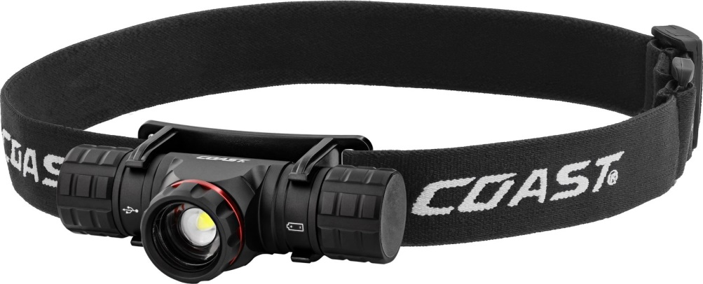

**“SL1 and SL1-R warning/safety lights”:**

**2 new compact safety lights** providing either Red or Red Flashing light modes **for personal safety use.**

Designed to **attach either by clip to work-vests, pockets, belts etc.**

Alternatively **can also be fixed directly onto the front or rear of any safety helmet** by using the 3M® Adhesive peel-off panel (supplied as standard)

**Can also be easily clipped onto the head-band of any brand of head-torch**, thus ***providing a secondary rear-safety light in red or flashing red***, to ensure wearer is highly visible from both the front and rear.

Maximum 30 hours continuous run-time , there are 2 options SL1 operates from single-use/disposable batteries whilst SL1-R operates from a li-ion rechargeable battery

***Pricing to Emergency Services personnel ranges from under £7 (SL1) version to £11.60 for the (SL1-R)***

 